Practicality Evaluationof TPACK-Integrated Vertebrate Zoology Teaching Materials Developed Using the Plomp Model
(Capitalize each word, 14 pt, bold, centered, not local info like school name, year)
Fabila Mahadira^{1*}, Yoona², Isyana Raisa Watson³, Keanu Dicaprio³, Taylor Swift⁴ (11 pt)
¹University of Pakuan, Bogor, Indonesia (11 pt)
²Seoul National University, Seoul, South Korea (11 pt)
³National Research and Innovation Agency, Cibinong, Indonesia (11 pt)
⁴New York University, New York, America (11 pt)
(Name of University or Institution, city, country)
*Email: fabilamahadira@unpak.ac.id (10 pt, italics)
Received: .......... Revised: .............. Accepted: ...........

Abstract (11 pt, bold, center)

This is the example of abstract. Please adjust your paper with template. The abstract text should be formatted using Times New Roman font 10. Leave 12 mm space after the abstract before you begin the main text of your article. The text of your article should start on the same page as the abstract. The abstract follows the addresses and should give readers concise information about the purpose, methods, and results. Do not put citation in your abstract. The maximum number of words in the abstract is 350 words.

Keywords: booklet; education; learning media; MBKM; Oryza sativa
INTRODUCTION (12 pt, bold)

The paper should be written in English. Do not change the margin of this template. Adjust the content of your paper with the template given. The body text should be written using Times New Roman font 11, single space, and justify paragraph. Give an indent for each paragraph within 5 letters of the left margin.
The introduction contains the background of the research, the research problems required, the latest related research, and the research objectives. The introduction must be supported by at least 10 international or national journal articles in the past 10 years. Do not put any tables or graphics in the introduction. Make sure that your writing is plagiarism free

METHOD (12 pt, bold)

The method contains the name, why the method is used, the research target/object, and the research location. Please put your research procedure clearly so that it is easy to read. Ensure you employ appropriate research methods in line with research problems with citations from international or national journal articles. Write the body text of the method section using Times New Roman font 11, single space, and justify paragraphs.
Math formula. Please submit math equations as editable text and not as images. Present simple formula in line with normal text where possible and use the default Microsoft Word Equation Editor, not other third party equation editors. In principle, variables are to be presented in italics. Number consecutively any equations that have to be displayed separately from the text (if referred to explicitly in the text).
Study Area
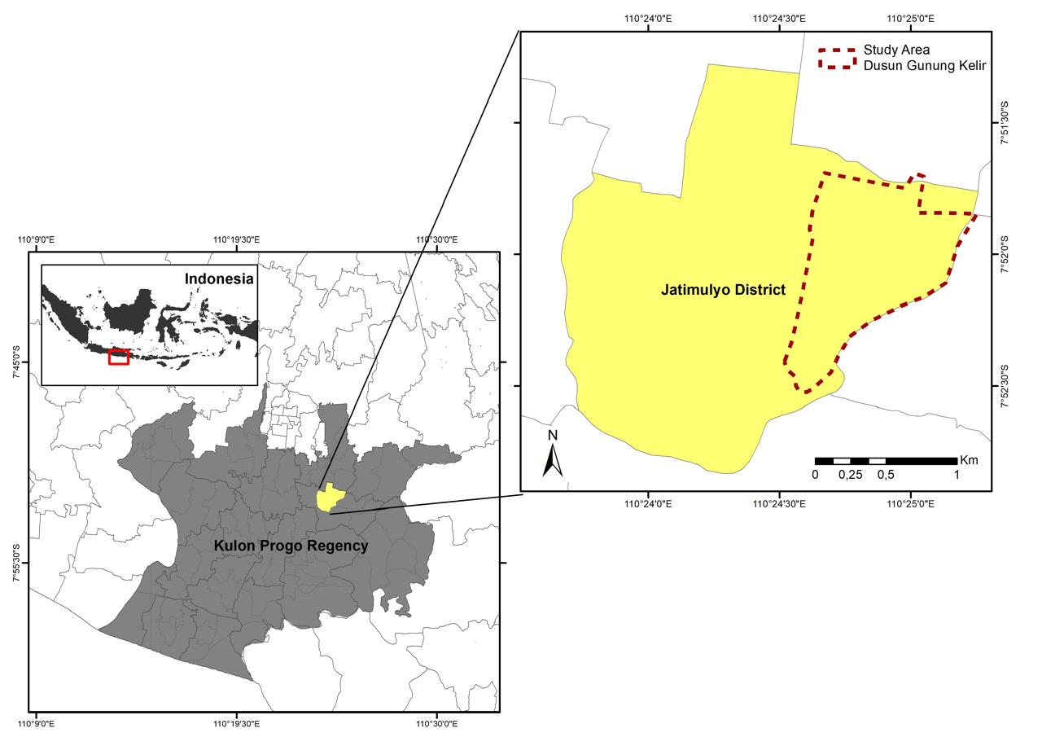

Figure 1. Location of research data collection (11 pt)
For research where samples are taken at certain locations, include a clear location map.
RESULT AND DISCUSSION (12 pt, bold)

In this section, you have to answer the research questions through research findings. Result and discussion of the research should be presented in a single unit Write the body text using Times New Roman font 11, single space, and justify paragraph. Some tables or figures can be presented to describe research data. This discussion includes a minimum of 10 citations originating from international and national journals within the last 10 years. This discussion reviews the results obtained and then links them to the literature. At the end of the paragraph, state the contribution of the research results to the country.
Example of Table
Table 1 shows the results data in measuring teachers’ response to a contextual-based book. Please adjust with your own data results. This is only an example. JBER cover the topics of biology education so that here we give you table concerning learning media. You may express your data in this table. Please adjust it with the template. The table is made with no column line. Please notice the following table to guide you how to display table in your paper. Tables are not images.

Table 1. Write caption above the table Give space 6 pt between caption and table (10 pt)
Indicator | Percentage(%) | Category
Presentation Feasibiliy | 83 | Good
Content Feasibiliy | 80 | Good
Graphic Feasibiliy | 81 | Good

Table 1 shows... please insert your explanation. Please add valid and reliable discussion. Furthermore, please add reference supporting your explanation.
Example of Figure
Please put the results of your research in the form of narration completed with figure or picture when it is needed. Add discussion to your research results accomplished with referring to adequate relevant source. This is only an example of how your text adjusted to our template. Several sentences and contents are written here to guide you follow the instruction. Please add valid and reliable discussion. Furthermore, please add valid and reliable discussion with supporting references. Make sure the image resolution is good and that if there is writing in the image, it can be read clearly.
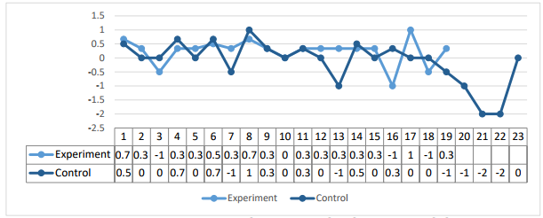

Figure 2. Student achievement at several cognitive levels (add explanation about the figure and put the figure at the centre)

CONCLUSION (12 pt, bold)

Conclusion should be written carefully in one paragraph using Times New Roman font 11, single space, and justify paragraph. The conclusion is prepared in just one paragraph, which conclude the research finding. Also provide a statement regarding the benefits of the research results for the country.

ACKNOWLEDGMENTS (12 pt, bold)

Authors wishing to acknowledge assistance or encouragement from colleagues, special work by technical staff or financial support from organizations. Please write it unnumbered. Acknowledgments section immediately following the last section of the paper.

AUTHOR CONTRIBUTIONS (12 pt, bold)
Author contributions follow the CRediT (Contributor Roles Taxonomy). Use only the contributor roles applicable to this manuscript.
Sample:
Conceptualization: Prof. AAA BBB, https://orcid.org/0000-0002-XXXX-XXXX
Methodology: Prof. BBB DDD, https://orcid.org/0000-0002-XXXX-XXXX
Formal analysis: Dr. CCC DDD, https://orcid.org/0000-0002-XXXX-XXXX
Investigation: Dr. DDD KKK, https://orcid.org/0000-0002-XXXX-XXXX
Writing – original draft: Prof AAA BBB, https://orcid.org/0000-0002-XXXX-XXXX
Writing – review & editing: Dr. BBB DDD, https://orcid.org/0000-0002-XXXX-XXXX
Supervision: Prof. CCC YYY, https://orcid.org/0000-0002-XXXX-XXXX

FUNDING (12 pt, bold)
Identify grants or other financial support (and the source, if appropriate) for your research and the role and influence of sponsor in this research.
Sample 1: This work was supported by YYYY Foundation [project number 888899999]. The funder had no role in study design, data collection, data analysis, manuscript preparation, or decision to publish.
Sample 2: This research received no external funding.

DECLARATION OF COMPETING INTEREST (12 pt, bold)
Sample 1: The authors declare that they have no known competing financial interests or personal relationships that could have appeared to influence the work reported in this paper.
Sample 2: One or more authors have the following competing interests...
Sample 3: Prof. XXX YYYY serves on the editorial board of this journal but had no involvement in the peer-review process.

USE OF ARTIFICIAL INTELLIGENCE (12 pt, bold)
Sample 1: The authors declare that no generative artificial intelligence (AI) tools were used in the conception, design, analysis, interpretation, or writing of this manuscript.
Sample 2: The authors used ChatGPT 5.6 solely for language editing and grammar improvement. The authors reviewed and verified all AI-assisted revisions and take full responsibility for the final content of the manuscript.
Sample 3: Generative AI was used to assist in drafting portions of the manuscript. All AI-generated text was critically reviewed, revised, and verified by the authors. The authors assume full responsibility for the accuracy and integrity of the final manuscript.
Sample 4: Generative AI tools (ChatGPT 5.6 and Gemini 3.5) were used to assist with programming and data analysis. All generated code and analytical outputs were independently validated by the authors before use in this study.
Sample 5: Generative AI (ChatGPT 5.6 and Gemini 3.5) was used to create illustrative figures in this manuscript. All figures were reviewed and approved by the authors, and their use is fully disclosed.
Sample 6: Generative AI tools (ChatGPT 5.6, Gemini 3.5, Grok 3.5) were used to assist in organizing literature and summarizing references. The authors independently verified all cited sources and interpretations.
Sample 7: The authors used generative AI tools (ChatGPT 5.6 and Claude Sonnet 5) to assist with language editing, programming, and manuscript preparation. All AI-generated content was reviewed, corrected, and verified by the authors, who take full responsibility for the accuracy and originality of the published work.
Sample 8: Please write statements in your own words, to reflect the use of AI in your manuscript.

DATA AVAILABILITY (OPTIONAL) (12 pt, bold)
Indicate where the research data can be accessed, provided participant confidentiality is maintained

REFERENCES (12 pt, bold)

Citation and references must be written using Times New Roman font 11, single space, based on APA style 7th edition which is organized by using Mendeley software latest version. References should contain minimum 20 citations which 80% from international and/ or national journal articles and 20% from another resources.

For Example:
Book
Bourn, D. (2018). Understanding global skills for 21st century professions. Switzerland: Springer Nature Switzerland AG.

Edited Book
Binkley, M., Erstad, O., Herman, J., Raizen, S., Ripley M., Miller-Ricci, M, & Rumble, M. (2012). Defining twenty-first century skills, dalam P. Griffin, E. Care, & B. McGraw (Eds), Assessment and Teaching of 21st century skills (pp. 15-21). London: Springer.

Journal article with one author
Cetin, P. S. (2014). Explicit argumentation instruction to facilitate conceptual understanding and argumentation skills. Research in Science & Technological Education, 32(1), 1-20.

Journal article with two authors
Bekiroglu, F. O., & Eskin, H. (2012). Examination of the relationship between engagement in scientific argumentation and conceptual knowledge. International Journal of Science and Mathematics Education, 10(6), 1415-1443.
Journal Article with three to six authors
Chung, Y., Yoo, J., Kim, S.,W., Lee, H., & Zeidler, D., L. (2016). Enhancing students’ communication skills in the science classroom through socioscientific issues. International Journal of Science and Mathematics Education, 14(1), 1-27.

Article in an online website
Schwab, K. (2018). The fourth industrial revolution. Retrieved from https://www.weforum.org/about/the-fourth-industrial-revolution-by-klaus-schwab.

Conference or seminar papers in published proceedings print
Istiana, R., Pertiwi, M. P., Saputri, D. D., Utami, A. W. A., & Lathifah, S. S. (2020). Peningkatan ekonomi dan gizi masyarakat kelompok tani ternak Desa Tajur Halang Kecamatan Cijeruk Kabupaten Bogor melalui inovasi produk fermentasi kekayaan lokal. In P. Dewi (Eds.), Prosiding Seminar Nasional Biologi VIII (pp. 411-419). Semarang, Indonesia: LPPM Universitas Negeri Semarang.

Conference or seminar papers in published proceedings online
Kurniasih, S., Sutjihati, S., & Herawati, D. (2018). Scaffolding learning community through the implementation of lesson study in Biology Education Study Program Pakuan University. In D. Ardianto (Eds.), The 9th International Conference on Lesson Study (pp. 166-171). Bogor, Indonesia: Universitas Pakuan. Retrieved from https://icls9.unpak.ac.id/page/book-of-proceeding-icls9-2018.

